Signing up for the California CFLC takes 5 MINUTES!

Follow this process if you are shipping a firearm to any California FFL. If you would like us to do this process on your behalf, please email sales@ugimports.com and we will take care of it for you.

STEP 1: Click here: https://cflc.doj.ca.gov/
STEP 2: On the webpage that is displayed, click this button:
STEP 3: Fill out the form with the following information:
- Business name
- FFL license number
- FFL expiration date, or the date from your Letter of Continuing Authorization
- Physical address
- Business e-mail address
- Telephone number
- Fax number (optional)
- Name of a contact person
STEP 4: Choose a password to sign up!

AFTER SIGNUP IS COMPLETE
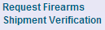
STEP 1: To request a shipment verification, log in and click on:

STEP 2: Fill out the online form:
- Recipient CL Number: Provided by receiving FFL (UG Imports: 21416)
- Number of firearms being shipped
- Invoice Number: This is for your reference, and can be whatever you want
STEP 3: On the last screen, verify the correct recipient FFL was found in their database:

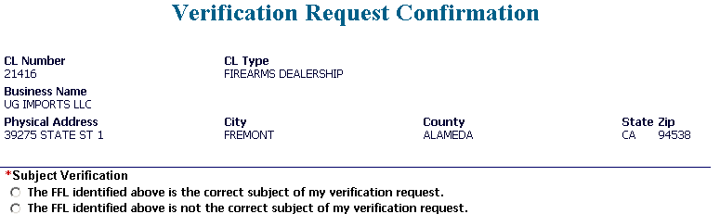
STEP 4: Provide the recipient FFL with the Approval Number on the confirmation page. For example:
The Approval Number is all I need. You don’t have to print the form, but you can keep a copy for your own records. Thanks!

Anthony Mendoza
UG Imports, LLC
Fremont, CA 94538
P: 510-371-4867 / F: 510-740-4443

